(Approx. 1615 words)

COMPLETE ROBOCALL DETERRENCE
A two-step approach: prevent the ring and convince the robocaller that your line is disconnected.
Part 1 of a 3-part article series
By John Krout, Presenter & Newsletter Contributor
Potomac Area Technology and Computer Society
https://www.patacs.org
jkrout.apcug.presenter (at) gmail.com

INTRODUCTION

Robocalls are a pervasive problem. The Washington Post reported in April 2019 that the estimated US volume of robocalls in March 2019 was 5.2 billion. That's a billion with a B. Divide 5.2 billion by 31 days, then 24 hours, and then 3,600 seconds. So, the number of robocalls per second was about 2,000.

Refusing to answer your smartphone is not enough. Robocaller systems are smarter than that; the systems won't stop calling. And the robocalls often jam your voicemail inbox.

The best deterrence is based on a thorough understanding of what automated robocall systems do. Then, we can use robocall system behaviors against the robocaller systems.

First, robocaller systems change their Caller IDs change constantly. Often, when placing 1,000 calls, a robocaller system can use as many as 1,000 different Caller IDs. Since most robocall deterrence apps and systems maintain a database of robocall Caller IDs, called a Blacklist, such databases always fall behind the robocaller Caller IDs. Second, robocaller systems often are based overseas, making it impossible for the US government to establish criminal jurisdiction. Third, robocaller systems keep a list of phone numbers known to have answered their robocalls in the past, even calls "answered" by a voicemail greeting. The robocall systems continue to call those phone numbers ad nauseum.

SPOOFING

First, robocall systems use a phone network behavior called spoofing to hide their real Caller IDs. That phone network behavior introduced many decades ago had and still has a valuable purpose for large phone sub-systems such as companies, hospitals, and the like.

Spoofing allows a caller to change the Caller ID shown to you when the customer calls you. The idea was to show the organization's main number, often the receptionist, even if the call was placed from technical support or Accounts Payable. This is appropriate for a large organization calling you back so that you can see a consistent and familiar Caller ID rather than one of the dozens or hundreds of phone lines used by the organization. That Caller ID replacement is done inside the phone network, based on commands sent by the caller system.

The bad news is that the phone network never imposed any security or restraints on Caller ID replacement.

The key thing to know is that automated robocaller systems often use spoofing to change their Caller IDs and with impunity. Often robocall systems use a spoofed Caller ID, including your area code and even your exchange (the three digits after the area code), to appear to be a call originating locally. The systems might even show a caller ID for a live local phone number. The systems seldom use the same ten-digit number twice to dodge Blacklist enforcement.

WHITELIST: AN ALTERNATIVE TO BLACKLIST

In the area of robocall deterrence based on Caller ID, the most powerful strategy for you is Whitelist, meaning configuring your phone to accept incoming calls only from the numbers in your phone's Contacts.

I have used that method on my phone since roughly September 2019. Paul Brandus, a Marketwatch.com columnist, had asked his readers to send in their own personal fixes for robocalls. Brandus published the most interesting reader responses in September 2019.

Brandus did not publish details of Whitelist configuration but did provide enough info to figure out the details on my own.

WHITELIST BEHAVIOR OUTLINE

The Settings feature you need to find in any iPhone or Android phone is called Do Not Disturb. The Settings app may allow you to type in a search term to find the place in the Settings app where you can access the feature. Use Settings search to find Do Not Disturb.

Here's the basic purpose of Do Not Disturb: don't ring the phone. It is not the same as Airplane mode, which disconnects your phone from the cell tower network; when Do Not Disturb is on, the phone stays connected to the cell tower network. You can place calls and read and write emails and text messages while using Do Not Disturb with Whitelist configuration.

And, very importantly, you can configure an exception to Do Not Disturb. The exception I have chosen are calls from my Contacts list. That turns this configuration into a Whitelist behavior. Calls from my Contacts will ring my phone. Other calls will not.

Once in a while, I have to turn off Do Not Disturb, for instance, if I expect a call from my state's COVID vaccine management office. Of course, I have no idea what that number might be.

So, yet another feature of Do Not Disturb becomes very valuable. It is possible to configure the phone to resume Do Not Disturb on a schedule automatically. For example, I have my phone set to continue Do Not Disturb at 10 PM local time. That way, I do not have to remember to re-enable Do Not Disturb after the expected call comes in. Unfortunately, the scheduling system requires you to specify a time range when Do Not Disturb will be in effect.

The complete Android Whitelist configuration steps are captured from my Samsung Galaxy S10 running Android 11 OS. Before Android 11 was available, I was able to do the same setup using Android 10, although the step details differed in some minor ways.
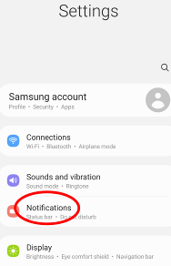Illustration 1
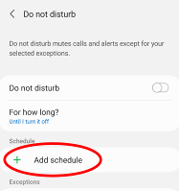Illustration 3
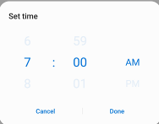Illustration 5
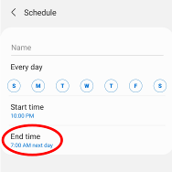Illustration 4
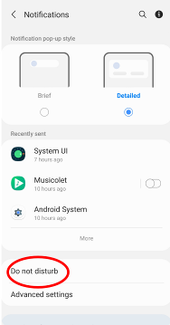Illustration 2

STEP 1. Open the Settings app. See Illustration 1 for the main screen of the Settings app. In that screen, tap the Notifications choice, which is circled in Illustration 1.

STEP2. The Notifications screen opens, as shown in Illustration 2. In that screen, find the Do Not Disturb choice, which is circled in Illustration 2.

STEP3. The Do Not Disturb screen opens, as shown in Illustration 3. On that screen, tap the phrase Add Schedule, which is circled in the illustration.

STEP 4. The Schedule screen opens, as shown in Illustration 4. In that screen, make sure all seven days of the week are selected.

STEP 5. Then tap the End Time, which opens a time adjustment window, shown in Illustration 5. Change that to 9:59 PM the next day. Each of the three parts (hour, minute, and AM/PM) can be adjusted by swiping up and down.

At the lower right corner of the window, tap the Done button. The window closes.

STEP 6. In the Schedule screen, in the Name field above the weekday list, type a name such as 24 hours.

STEP 7. At the bottom of the Schedule screen, tap the Save button (not shown). The Schedule Screen closes, and the Do Not Disturb screen reappears. The schedule name and hours now appear under the Schedule heading on the screen.
STEP 8. In the Do Not Disturb screen, tap Calls, Messages, and Conversations under the Exceptions heading, which is circled in Illustration 6. That tap opens the Calls, messages, and conversations screen, as shown in Illustration 7.
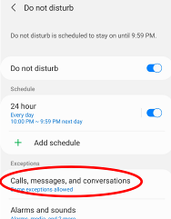Illustration 6
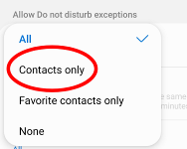Illustration 8

STEP 9. In the Calls, messages, and conversations screen, tap the word Calls, which is circled in Illustration 7. A menu appears, as shown in Illustration 8.
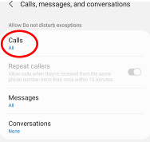Illustration 7
STEP 10. In the menu, tap the Contacts Only choice. The menu closes, and the phrase Contacts only appears below the word Calls. At the top of the screen, tap the left arrow to return to the Do Not Disturb screen.

STEP 11. In the Do Not Disturb Screen, tap the Hide Notifications heading. The Hide notifications screen appears. Turn off all of the switches on that screen. At the top of the screen, tap the left arrow to return to the Do Not Disturb screen.

STEP 12. In the Do Not Disturb screen, turn on the Do Not Disturb switch. You can see that switch in Illustration 3.

Note: that same Do Not Disturb switch can be used to disable Do Not Disturb when you expect a legitimate incoming call from someone outside of your Contacts list. Due to the automatic schedule, you won't have to turn on Do Not Disturb manually; the phone will do it for you.

That's it. Your Android phone is configured for Whitelist behavior. Exit the Settings app.

IPHONE DO NOT DISTURB

I identified similar Whitelist settings on my corporate iPhone 6s. Due to corporate policy issues, I was unable to apply and test the iPhone Whitelist settings. The basics are very similar to Android: in Settings, find Do Not Disturb. Set a schedule, set an exception for Contacts, and turn off Hide Notifications.

NEXT UP

In part 2 of this article series, you will learn how to convince robocaller systems that your phone number is not in service, so they won't call you again, and how to assemble a combination of your voice and other sounds in a voicemail greeting for that purpose.

ABOUT THE AUTHOR: John Krout has been writing about creative uses of personal computers since the early 1980s, and more recently, about creative uses of smartphones. He finished a long career as a software engineer with 14 years as a technical writer for a federal contractor. He lives in Arlington, Virginia, with his son, many computers and cameras, and too many cats.
______________________________________________________________________

NEWSLETTER EDITOR NOTES: Due to the large number of screen captures used as illustrations in this article, your author has carefully overlapped the illustrations to save space while ensuring that the important user interface features discussed in the article are visible. Please consider using the same overlapping illustration arrangement in your newsletter to save space.

